**ASSIGNMENT-6**

**AIM:-**

Database Trigger (Row level and Statement level triggers, Before and After

Triggers):Write a database trigger on Employee table. The System should

Keep track of the records that are being updated or deleted. The old value of updated or

Deleted records should be added into a new table when the Employee table is

updated. Employee (employee no, employee name, join_date, designation,

salary).

**OBJECTIVE**:-

To implement row and statement level trigger.

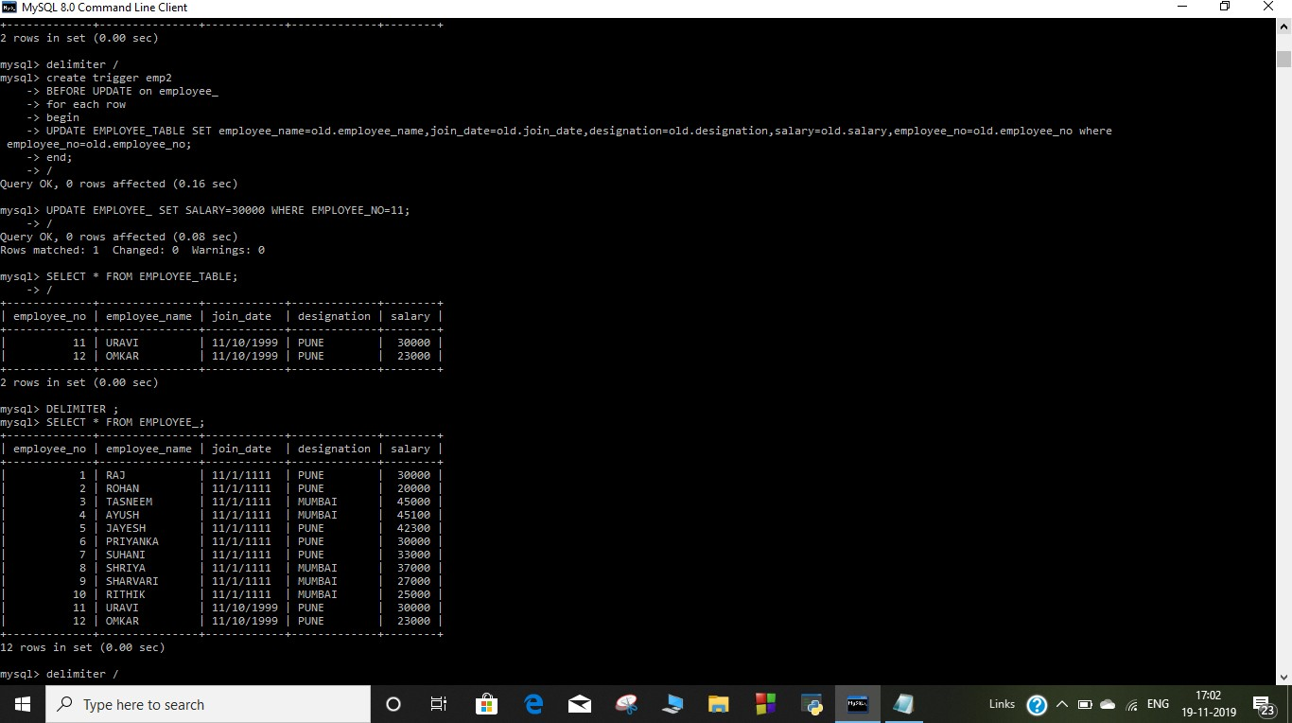OUTPUT:

